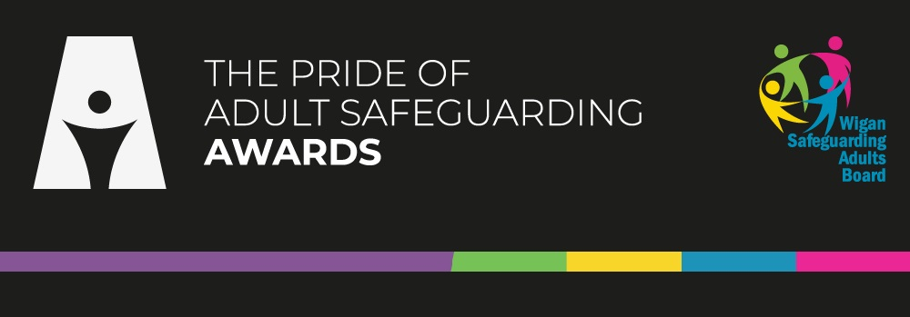

Pride of Adults Safeguarding Awards Nomination form
Please note: This form is intended to help you save your responses before submitting them via our online submission system. Any answers entered into this template will need to be copied and pasted into the online system at the point of final submission. Further guidance is available on our website under How to Nominate
Data Protection | Agree | Do not Agree
By submitting a nomination, you are consenting to the processing of your personal data necessary for the administration of the award and you are confirming that you have the consent of any nominees for the processing of their personal data. Any personal data submitted as part of the nomination process will be stored on the Wigan Council cloud server and shared with the WSAB partners for shortlisting. Details of the nomination without your personal details and the nominee will then be shared with our What’s Up Champions for adjudication to take place. Personal data will be retained for up to 7 years after the awards have taken place. To see how Wigan Council processes your personal data, please see the privacy notices web page. | ☐ | ☐
Please note are only able to process nominations with both the consent of yourself to process your personal data and the nominee to process their personal data.
Your Details
First Name
Surname
Are you a professional submitting this nomination? | Yes / No
Job Title (if required)
What Organisation are you part of? (if required)
Email Address
Telephone No.

Details of Person you are Nominating
First Name
Surname
Are they a professional? | Yes / No
Job Title (if required)
What Organisation are you part of? (if required)
Email Address
Telephone No.

Award Category - Please select below a category - for detailed information on categories please visit the Adult Safeguarding Awards webpage.
Empowerment | ☐
Prevention | ☐
Proportionality | ☐
Protection | ☐
Partnership | ☐
Accountability | ☐

Details of Nomination
Details in this section should not contain any personal data other than the details you have submitted on previous pages of this nomination. Any write ups should by anonymised appropriately ensuring we cannot identify any individuals, even indirectly. You can use options such as Person A etc.
All submissions should be referenced back to the award criteria which can be found on the How to Nominate webpage.
Summary of nomination
Please insert relevant dates of when the work was undertaken
Impact
What impact has this this work had?
Making Safeguarding Personal
'Making Safeguarding Personal' (MSP) is an approach to Safeguarding that aims to ensure that the Person (adult at risk) and/or their advocate in relation to the safeguarding enquiry, are fully engaged and consulted throughout and that their wishes and views are central to the final outcomes as far as is possible. Please outline below how this nomination ensured that MSP was displayed by the nominee
Legacy
Does this work have a legacy that goes beyond the piece of work undertaken, how will this influence future safeguarding?
Further evidence or any other comments to support this application (optional)

I have checked the contents of my submission, and it does not contain any personal information that is likely to identify others
Yes / No
Today’s Date: | Click or tap to enter a date.

Where did you hear about our awards?
Word of mouth | ☐
Social media | ☐
WSAB Webpage | ☐
From an event | ☐
From multi-agency meeting | ☐
From a line manager | ☐
Rather not say | ☐
Other | ☐

I hereby declare that the information provided is true and correct
Yes / No

